VBS – PIPELINE   
============================================  
Vault details   
SMTP : DEV1_SMTP_1  
Fusion : DEV1_FUSION   
ATP : DEV1_ATP_1  
  
step need to follow

========================

1. need to make the changes in the readinputfile.py

need to add the vault_id

because we are creating the valut and placing the credentails in the vault so that we need the

valut id

2. we need to make the change by clicking on the step 1 and then click on the setting symbol

and the VM which we are using on the build executor in the organization tab

The Build executor will have the necessary software which are need for the builds

3. click on the hammer symbol which is above the setting symbol and the add the fusion url

by remove the link till.com and add the fusion url for the both external and internal

4. in the steps add the oci details like oci id, fingerprint,region and other things which are mentioned above

5. then click the save button

continue the steps for all the steps in the pipe line and then click on save for each and every build job

NOte :

build job can be opened by right clicking on it and then click on the new tab it will open in the new tab

then select the configure and then add the credentails,git changes

 Working Flow   
==================

Step 1 : Project Administration  
  
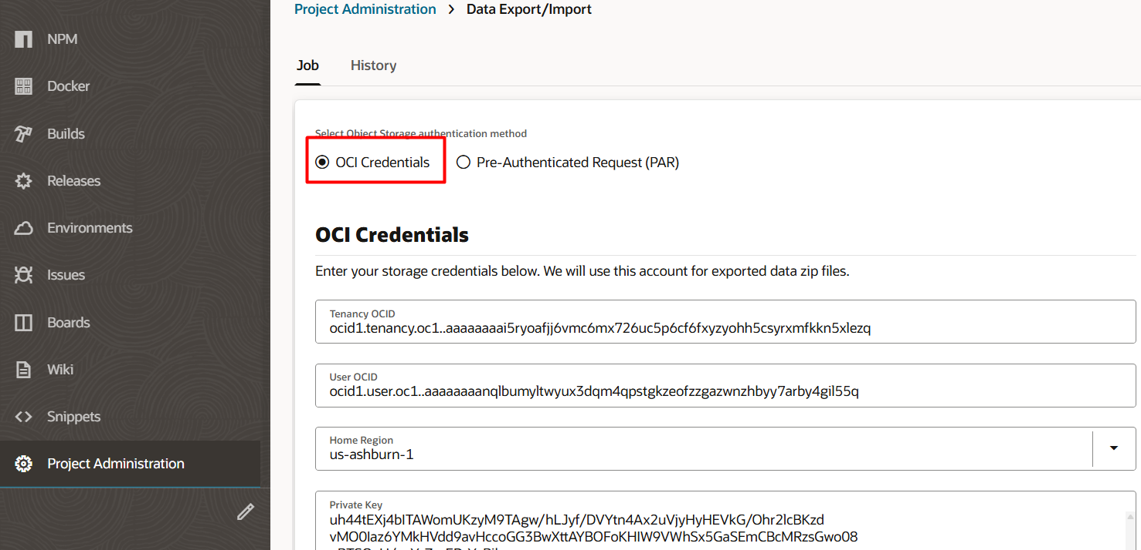  
  
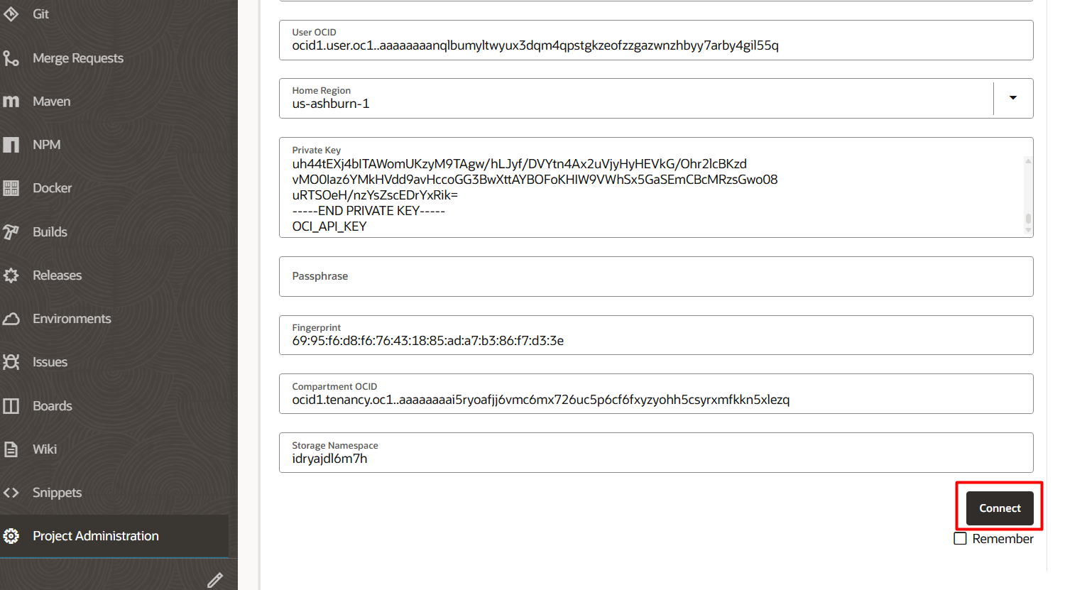  
  
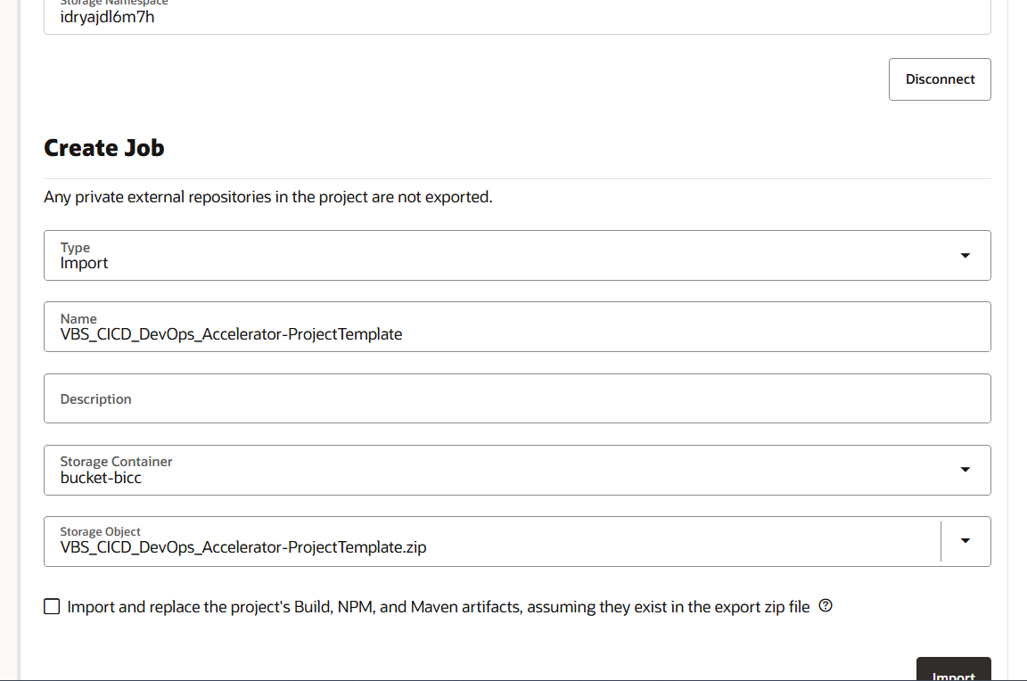  
  
after importing the file , click on the git – external and internal git for the pipeline  
  
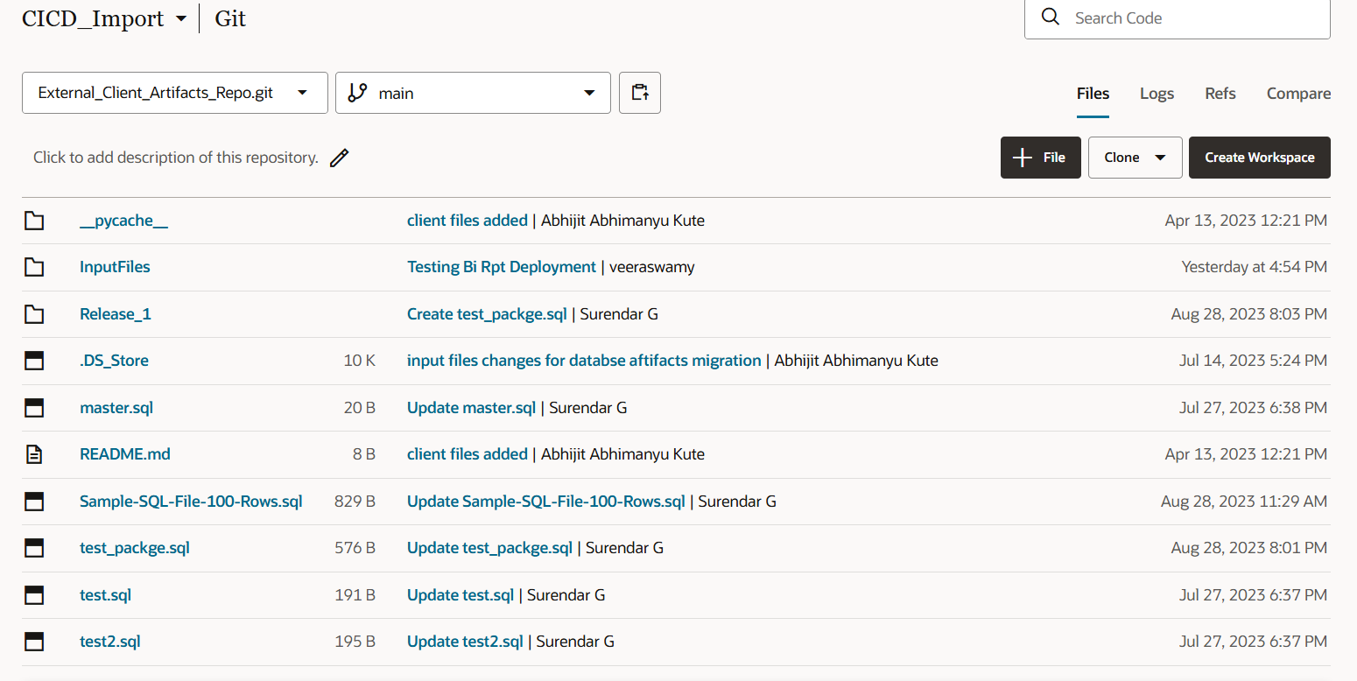  
  
external git  
================  
input file – we have an excel file that contains the BI report location and the path , with the name of the BI-Report   
  
when the files is open   
  
the file location is the place where the file is going to be placed in the fusion

It will be placed in the   
1. custom --🡪new1--🡪TERADYNE---🡪datamodel  
the new1 folder will be created in the custom folder and it will create a Teradyne and then this file will be moved to the datamodel

2.custom --🡪new1--🡪TERADYNE   
the new1 folder will be created in the custom folder and it will create a Teradyne  
   
The source data will be placed in the external git “Release_1”  
  
  
the BI report will be placed inside the BI Report folder as Xdm, xdo   
the database file will be placed inside the database folder as .sql

Then we can move that to the build

Select the build and then click on the configure   
  
it will open the first job in the new page  
  
job 2   
  
DEV1_FUSION – with the credentails we are creating a vault in the OIC   
  
vault_id="ocid1.vault.oc1.iad.ejurjoqaaahte.abuwcljsmbmhq7elzyjpfdweajchv3nvjblysoi5lq6bj6mhvgiwhy66bk2q"  
  
job 3   
  
job 4  
  
job 5   
  
job 6

DEV1_SMTP_1

ocid1.vault.oc1.iad.ejurjoqaaahte.abuwcljsmbmhq7elzyjpfdweajchv3nvjblysoi5lq6bj6mhvgiwhy66bk2q  
  
  
to edit the flow   
when I clicked on the edit on the success jobs --- it will show the next flow , if you delete the flow then select the flow which you want to connect.  
